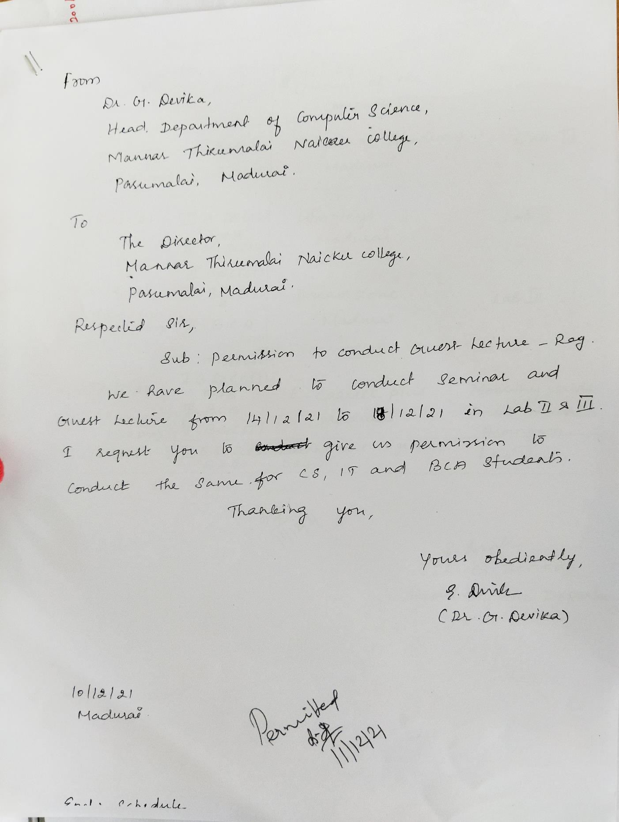**Permission Letter**

**WINWAYS INFOMATICS PRIVATE LIMITED**

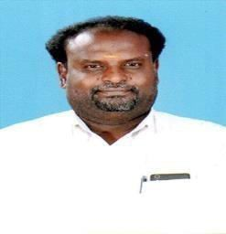

**J.S. Sukumar**

Director - Operations

***“I believe in giving clarification and information for technical aspirants to guide them which is so important in this knowledge era”***

* Entering into my **25th** year of service in guiding student’s community to grab dream position in the corporate industry as technical export or as an entrepreneur
* I have performed in various distinguished roles for this 25 year of tenure which includes, **Channel Sales, Marketing, Personnel, Administration, Quality Control, Audit and Training**
* Conducted more than 2**000 Seminars** on Faculty Development Program, Placement Training, Soft skill, Carrier Guidance, Communication course, Power of Opensource, Engineering skill set Guidance and Industrial knowledge Updating Workshops.
* My core strength is **People Management and Career Building**
* Strategy formulating and Documenting, Spreading Importance of Open Source, Planning and Organizing, Operations, Communication, Negotiating and Training are my passionate areas.
* Well equipped with the Novel technologies including E-commerce, Open Source and Knowledge Management
* Deep understanding of Open source technology and contributing to its proliferation has earned me the appreciation of late **Dr. A. P. J. Abdul Kalam.**
* WINWAYS is providing important information for upcoming technical students with the world’s No.1 Enterprise Linux creator “REDHAT”
* Explanation and information about earning International Certification in their interested technologies and domain to grab the unique seat in the corporate world.
* Details about various RED HAT certifications in Networking, Data Management, Cloud Computing, middleware and developing stack.

Reach me at: [**satsuku1971@gmail.com**](mailto:satsuku1971@gmail.com) **+91 98409 42455**

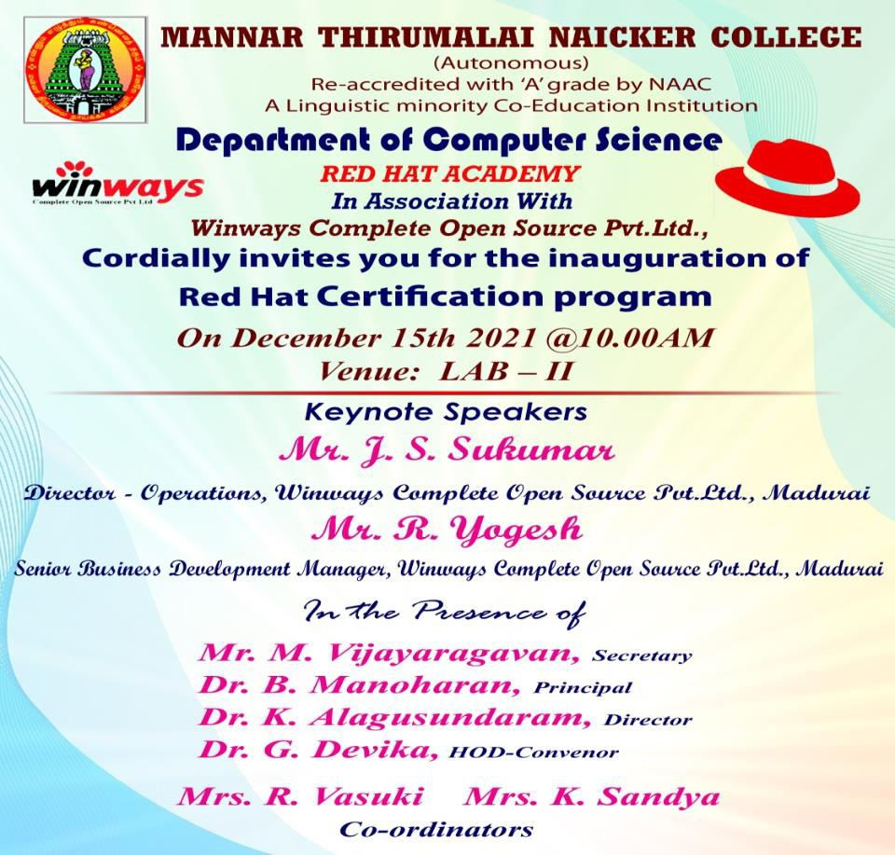

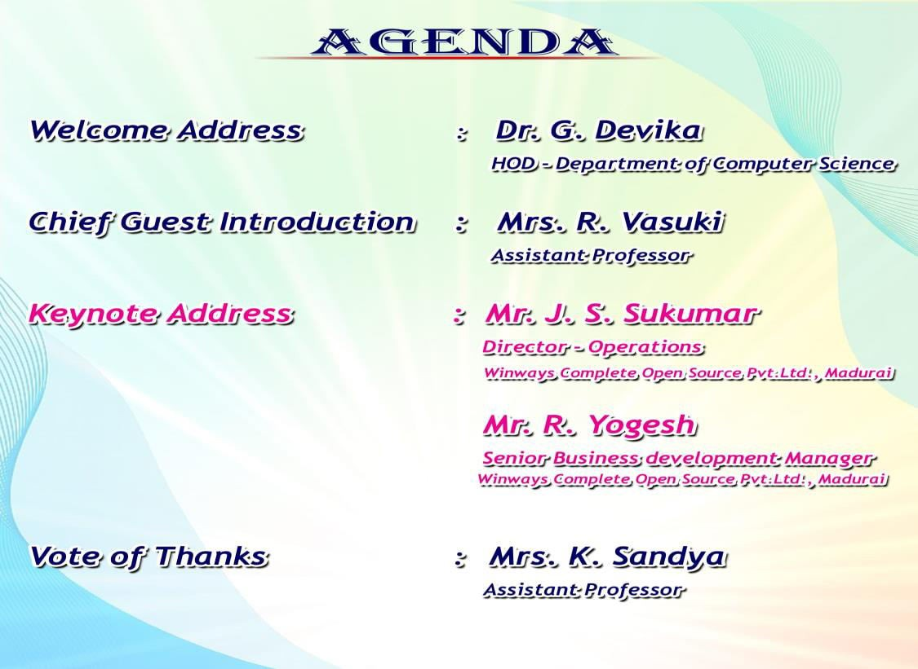

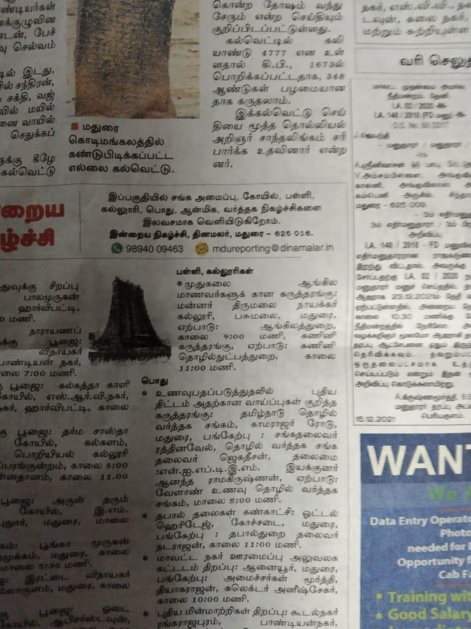

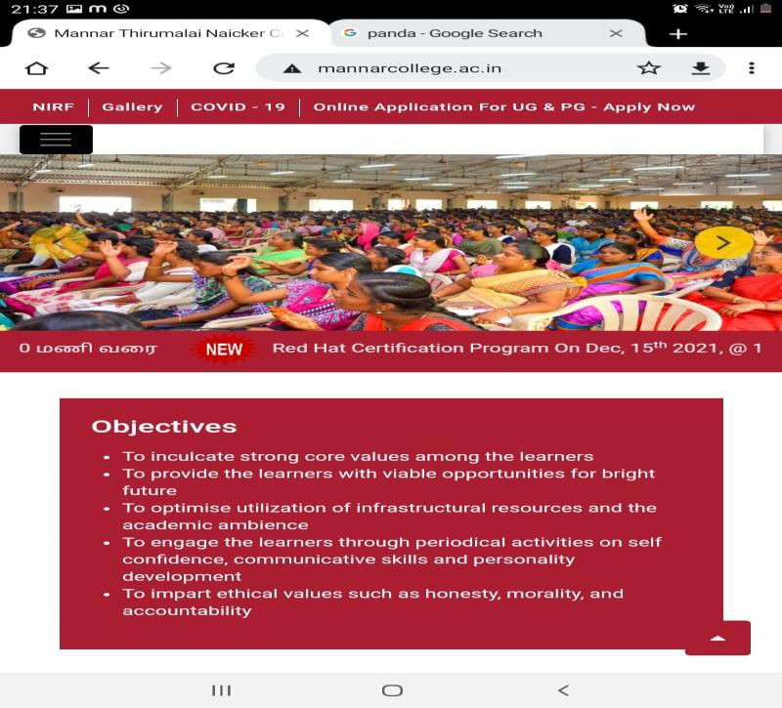

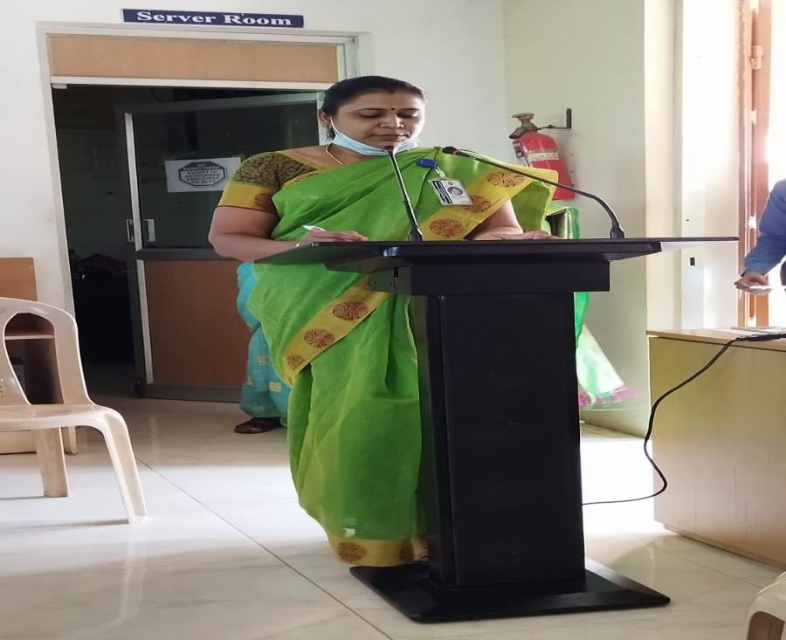

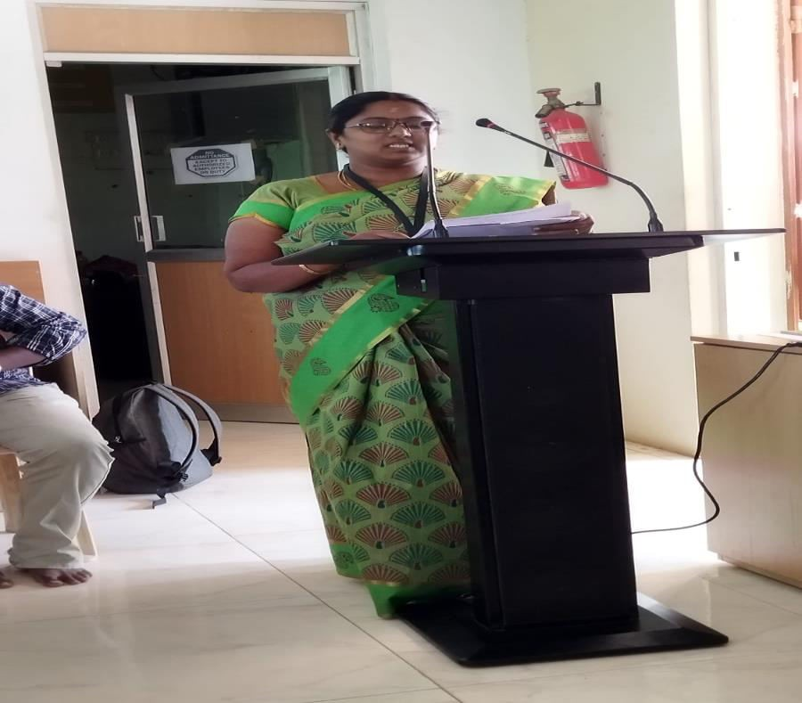

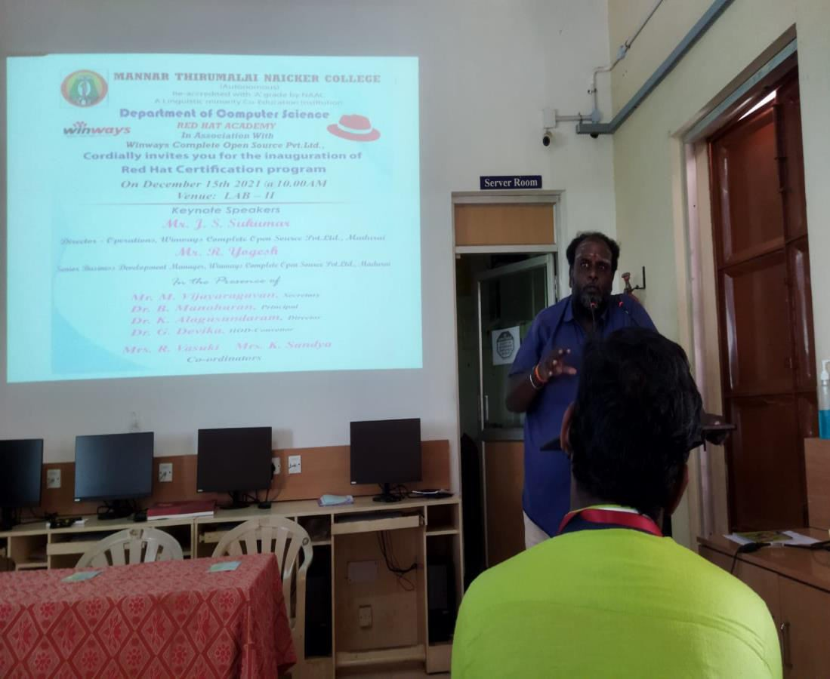

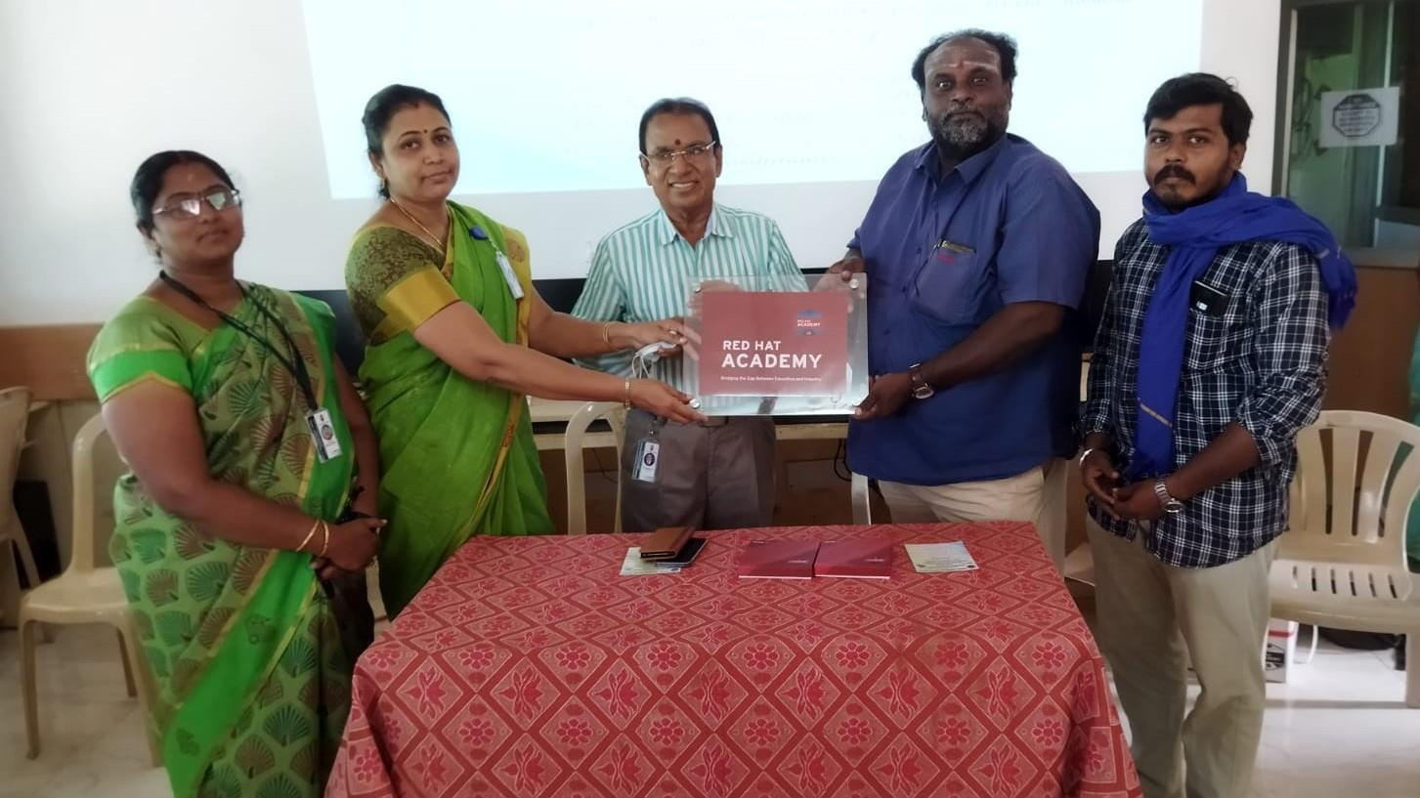

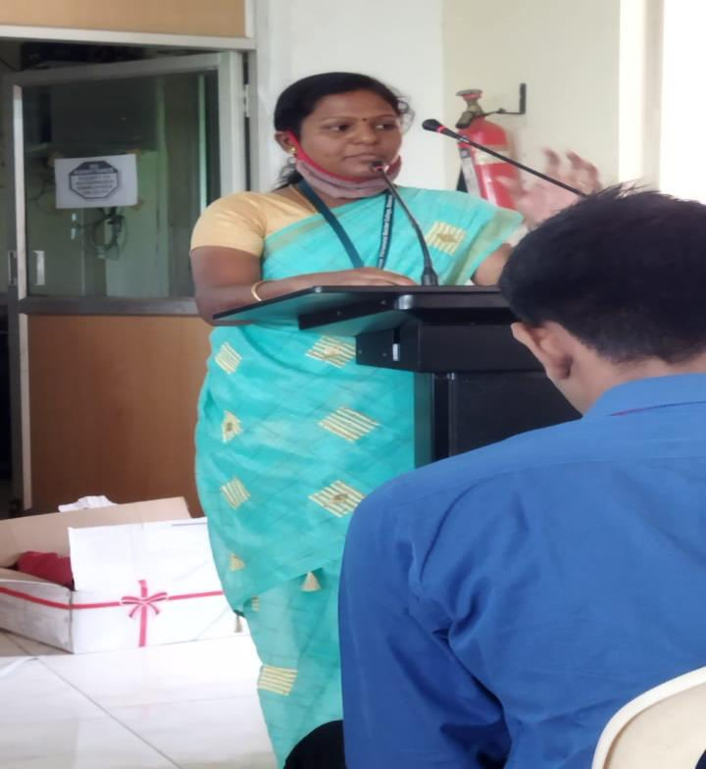

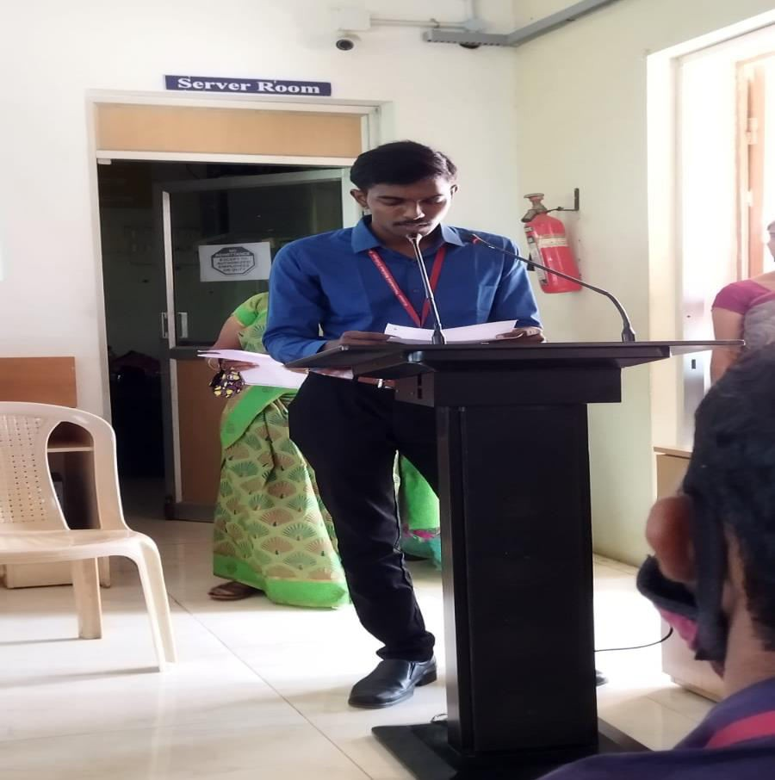

**REPORT ON RED HAT CERTIFICATION PROGRAM**

**“TRAINING ON LINUX OPERATING SYSTEM”**

**On**

**15th DECEMBER 2021**

Department of Computer Science organized a certificate course on “**Linux Operating System**" on **December 15 2021** in Lab II. This program was focused on working of **Linux Open Source Platform**. The program started at 10:30 am with tamiltaaivaazhthu. Following that, Dr.G.Devika presented the welcome address. Then Mrs.R.Vasuki gave an introduction about chief guests. The keynote address was given by Chief Guests Mr..S. Sukumar and Mr. R. Yogesh from Winways Complete Open Source PvtLtd Madurai.

He performed in various distinguished roles for this 25 year of tenure which includes, Channel Sales, Marketing, Personnel, Administration, Quality Control, Audit and Training. He conducted more than 2000 Seminars on Faculty Development Program, Placement Training, Soft skill, Carrier Guidance, Communication course, Power of Opensource, Engineering skill set Guidance and Industrial knowledge Updating Workshops. His core strength is People Management and Career Building.

His passionate areas are Strategy formulating and Documenting, Spreading Importance of Open Source, Planning and Organizing, Operations, Communication, Negotiating and Training. He is also Well equipped with the Novel technologies including E-commerce, Open Source and Knowledge Management. He gave them a preface about their company and Linux operating System.

R.Yogesh Kumar Completed MBA in the year of 2015 from The American College Madurai Immediate after completion of his post- graduation he started career as marketing executive in winways Madurai to enable IT services promotion incharge from the same year of 2015.In his six years of best services now he is the senior business development manager of winways Madurai. His passion towards open source is remarkable.

He interacts with students to ask some questions about program and students also answered his problem of LINUX open source operating system.

The vote thank was given by Mrs.K.Sandya Followed that played national anthem.

**CO-ORDINATORS SIGNATURE** **HOD SIGNATURE**

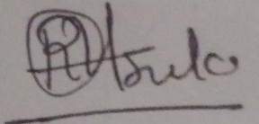 **Mrs.R.VASUKI** 

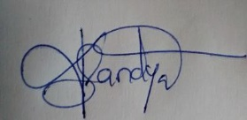 **Mrs.K.SANDYA**

